**Installation of Firebug**

**Firebug**is a Firefox add-on that we will use to **inspect the HTML elements** of the web application under test. It will provide us the name of the element that our Selenese command would act upon.

**Step 1**

Use Firefox to navigate to Firebug's download page (<https://getfirebug.com/downloads/>) and click on the download link.

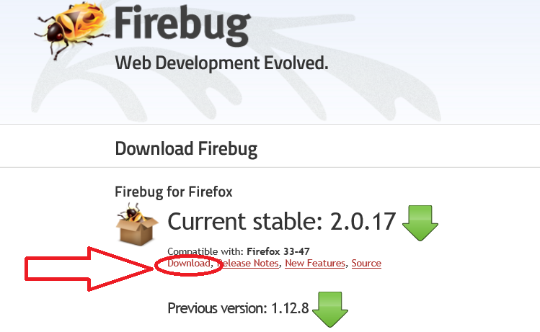

**Step 2**

Firefox will take you to its Firebug download section. Click the **"Add to Firefox"** button.

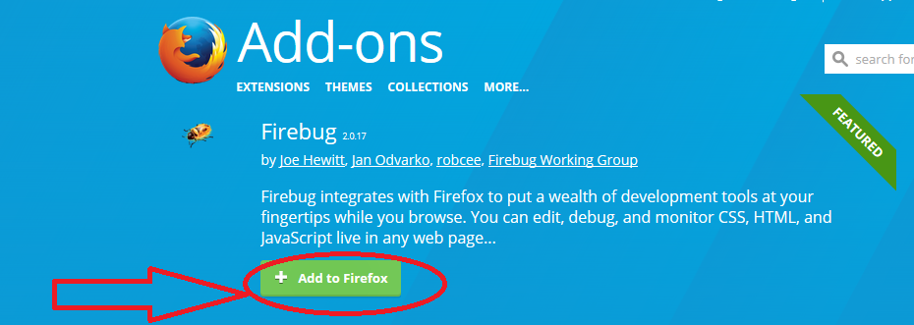

**Step 3**

Wait for Firefox to complete downloading this add-on. On the dialog box that comes after, click **"Install Now."**

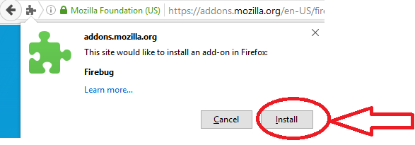

**Step 4**

Wait for the installation to complete. A notification will pop-up saying, "Firebug has been installed successfully." You can immediately close this pop-up.

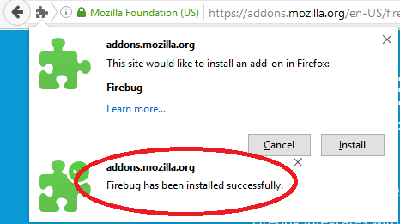

[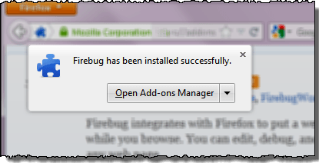](http://cdn.guru99.com/images/firebug_-_successfully_installed.png)

**Note**: In case if you do not see above pop-up, no worries! This pop-up appears for a few seconds and disappears.

You do not need to restart Firefox after installing Firebug.

**Step 5**

Launch Firebug by doing either of these two methods:

* Press **F12**
* Click on the **Firebug button** on the upper right corner of the Firefox window.

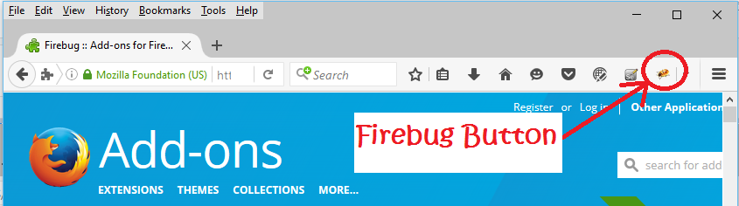

**Step 6**

Firebug should launch **at the bottom of Firefox**as shown below

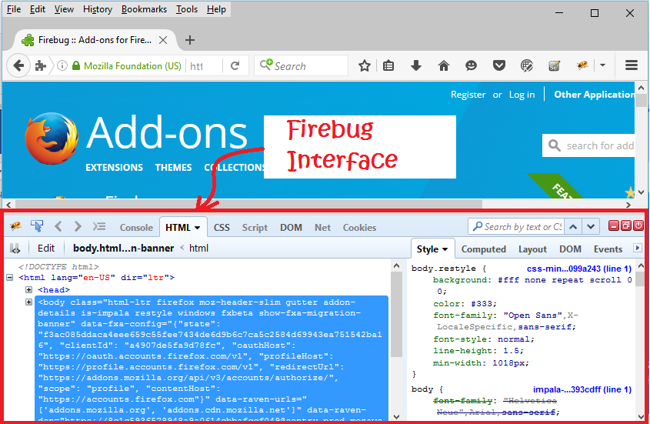

**Plugins**

**Selenium IDE can support additional Firefox add-ons or plugins created by other users**. You can visit [here](https://addons.mozilla.org/en-US/firefox/addon/selenium-expert-selenium-ide/) for a list of Selenium add-ons available to date. Install them just as you do with other Firefox add-ons.

By default, Selenium IDE comes bundled with 4 plugins:

1.    Selenium IDE: C# Formatters

2.    Selenium IDE: Java Formatters

3.    Selenium IDE: Python Formatters

4.    Selenium IDE: Ruby Formatters

These four plugins are required by Selenium IDE to convert Selenese into different formats.

**The Plugins tab shows a list of all your installed add-ons, together with the version number and name of the creator of each.**

[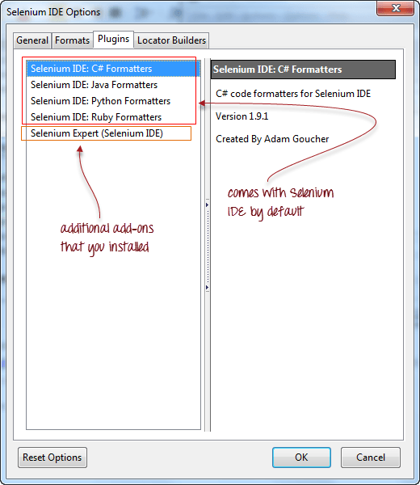](http://cdn.guru99.com/images/plugins_list.png)

**User Extensions**

Selenium IDE can support user extensions to provide advanced capabilities. User extensions are in the form of JavaScript files. You install them by specifying their absolute path in either of these two fields in the Options dialog box.

* Selenium Core extensions (user-extensions.js)
* Selenium IDE extensions

[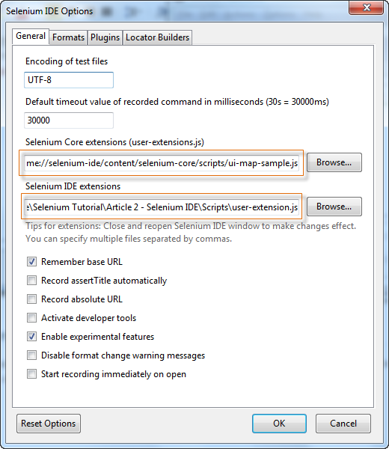](http://cdn.guru99.com/images/user_extensions.png)